Experiment NO: 5 Date:
Aim: To implement Decision trees.

Theory: Decision Trees are predictive models used in machine learning and data analysis for making decisions by learning simple decision rules inferred from data features. They are a popular supervised learning method that can perform both classification and regression tasks.
During training, the Decision Tree algorithm selects the best attribute to split the data based on a metric such as entropy or Gini impurity, which measures the level of impurity or randomness in the subsets. The goal is to find the attribute that maximizes the information gain or the reduction in impurity after the split.
Construction of Decision Tree: A tree can be “learned” by splitting the source set into subsets based on Attribute Selection Measures. Attribute selection measure (ASM) is a criterion used in decision tree algorithms to evaluate the usefulness of different attributes for splitting a dataset. The goal of ASM is to identify the attribute that will create the most homogeneous subsets of data after the split, thereby maximizing the information gain. This process is repeated on each derived subset in a recursive manner called recursive partitioning. The recursion is completed when the subset at a node all has the same value of the target variable, or when splitting no longer adds value to the predictions. The construction of a decision tree classifier does not require any domain knowledge or parameter setting and therefore is appropriate for exploratory knowledge discovery. Decision trees can handle high-dimensional data.
Code:
11/9/23, 10:05 PM decision_tree file:///C:/P Jeevesh Naidu/college/honours/sem 5/decision_tree.html 1/2

In [ ]:
import pandas as pd from sklearn.datasets
import load_breast_cancer

In [ ]:
data = load_breast_cancer()
dataset = pd.DataFrame(data=data['data'], columns=data['feature_names'])
dataset

Out[ ]:

ean dius | mean texture |  | mean perimeter |  | mean area |  | mean smoothness |  | mean compactness |  | mean concavity |  | mean concave points |  | mea symmetr
7.99 | 10.38 |  | 122.80 |  | 1001.0 |  | 0.11840 |  | 0.27760 |  | 0.30010 |  | 0.14710 |  | 0.241
0.57 | 17.77 |  | 132.90 |  | 1326.0 |  | 0.08474 |  | 0.07864 |  | 0.08690 |  | 0.07017 |  | 0.181
9.69 | 21.25 |  | 130.00 |  | 1203.0 |  | 0.10960 |  | 0.15990 |  | 0.19740 |  | 0.12790 |  | 0.206
.42 | 20.38 |  | 77.58 |  | 386.1 |  | 0.14250 |  | 0.28390 |  | 0.24140 |  | 0.10520 |  | 0.259
0.29 | 14.34 |  | 135.10 |  | 1297.0 |  | 0.10030 |  | 0.13280 |  | 0.19800 |  | 0.10430 |  | 0.180
... |  | ... |  | ... |  | ... |  | ... |  | ... |  | ... |  | ...
.56 | 22.39 |  | 142.00 |  | 1479.0 |  | 0.11100 |  | 0.11590 |  | 0.24390 |  | 0.13890 |  | 0.172
0.13 | 28.25 |  | 131.20 |  | 1261.0 |  | 0.09780 |  | 0.10340 |  | 0.14400 |  | 0.09791 |  | 0.175
6.60 | 28.08 |  | 108.30 |  | 858.1 |  | 0.08455 |  | 0.10230 |  | 0.09251 |  | 0.05302 |  | 0.159
0.60 | 29.33 |  | 140.10 |  | 1265.0 |  | 0.11780 |  | 0.27700 |  | 0.35140 |  | 0.15200 |  | 0.239
7.76 | 24.54 |  | 47.92 |  | 181.0 |  | 0.05263 |  | 0.04362 |  | 0.00000 |  | 0.00000 |  | 0.158

In [ ]:
from sklearn.model_selection import train_test_split
X = dataset.copy()
y = data['target']
X_train, X_test, y_train, y_test = train_test_split(X, y, test_size=0.33)

In [ ]:
from sklearn.tree import DecisionTreeClassifier
clf = DecisionTreeClassifier(ccp_alpha=0.01)
clf = clf.fit(X_train, y_train)

In [ ]:
feature_names = X.columns
feature_names

Out[ ]:
Index(['mean radius', 'mean texture', 'mean perimeter', 'mean area', 'mean smoothness', 'mean compactness', 'mean concavity', 'mean concave points', 'mean symmetry', 'mean fractal dimension', 'radius error', 'texture error', 'perimeter error', 'area error', 'smoothness error', 'compactness error', 'concavity error', 'concave points error', 'symmetry error', 'fractal dimension error', 'worst radius', 'worst texture', 'worst perimeter', 'worst area', 'worst smoothness', 'worst compactness', 'worst concavity', 'worst concave points', 'worst symmetry', 'worst fractal dimension'], dtype='object')

In [ ]:
from sklearn import tree from
matplotlib import pyplot as plt
fig = plt.figure(figsize=(25,20))
_ = tree.plot_tree(clf, feature_names=feature_names, class_names={0:'Malignant', 1:'Benign'}, filled=True, fontsize=12)

Out[ ]:
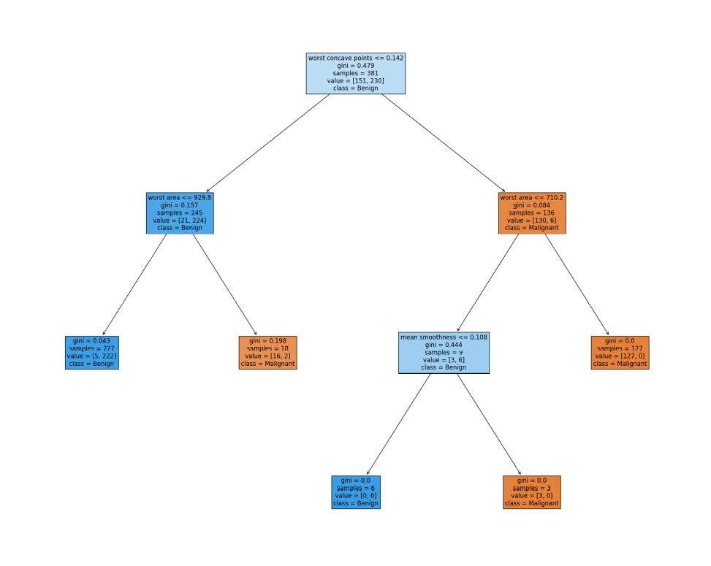

Conclusion:
Decision trees were studied and successfully implemented.

